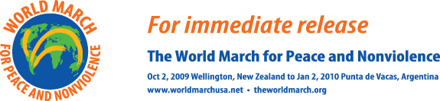
Contact: Nicole Myers, tel: 917-609-8029

M E D I A A L E R T
Bernard Lafayette to lead the World March for Peace and Nonviolence across Brooklyn Bridge

What: The World March for Peace and Nonviolence starts a three-day tour of the USA with a March over the Brooklyn Bridge led by Dr. Bernard Lafayette, Civil Rights activist and adviser to Martin Luther King.
When: Monday Nov 30, starts 1 pm, finishing 3pm
Where: Starting at Brooklyn Boro Hall to City Hall, via the Brooklyn Bridge.
Who: The international base team of the World March for Peace and Nonviolence with their international Spokesperson, Rafael de la Rubia, Dr. BernardLafayette, hundreds of nonviolence activists from around the State, all the students and teachers at Brooklyn International High School and others, religious leaders, Consuls and New York City Council Members.
Why: The World March for Peace and Nonviolence is travelling through 100 countries on 6 continents calling for the complete elimination of nuclear weapons and the withdrawal of troops from foreign territories among others. Starting on 2nd October in Wellington, New Zealand, the March is due to arrive in Punta de Vacas, Argentina on the 2nd of January at the end of a 93 day tour.
Endorsements: Presidents of 11 countries; Desmond Tutu, Jimmy Carter, Noam Chomsky, Cornel West, Dennis Kucinich, Daniel Ellsberg, Cate Blanchett, Martin Sheen, Yoko Ono, Art Garfunkel, Philip Glass, Ad Asner and hundreds more.
For a complete list, go to www.theworldmarch.org

